Child Friendly Privacy Notice | - Who are we?  We are a Nottinghamshire County Council School. We provide education to students with special needs aged from 3 -18 | 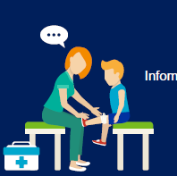  4. How do we collect information about you?  Information you tell us and information others, such as your family, doctors or other therapist.  We use this information to ensure we provide the care and education you need. | 6. How long do we keep your information for?  We keep your information whilst you are at the school.  When you leave, key information will be transferred to your new school or college.  Otherwise, it will be kept by the school until you reach your 25th Birthday.
- Why we keep personal information about you?    We aim to give you the best possible education and care. To do this we keep records about you |  | 5. How do we use your information?  We securely hold information about you so we can deliver your education and care.  We share information about you:  For example  - The police if they are investigating a serious crime.  - The court has asked for information.  - When our services are inspected  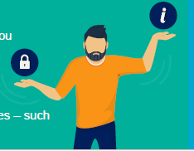  - To help our staff teach and look after you.  - If we feel there is risk of harm to yourself or others | 7. Your rights  - We only keep information about you that we really need to  - We do not share it unless we must.  - The law gives you the right to know what information we hold about you and to have a copy of this information.  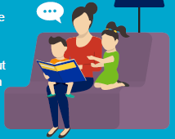  - There are some other rights – such as the right to have incorrect information amended
3. What information do we keep about you?
The information we keep includes:
- Your name and where you live.
- Who cares for you and who you live with.
- Services you use.
- A copy of your EHCP
- School attendance and behaviour information
- Information about your progress

