Book of the week: GIRAFFES CAN'T DANCE
Written by Giles Andreae. Illustrated by Giles Parker Rees. Published by Orchard Books 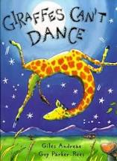

Story link: https://watch.vooks.com/free-access/videos/giraffes-can-t-dance
This week’s story is all about a giraffe who wanted to learn how to dance, can he do it?
After you have listened to or read the book, if you have it, try some of the following to help with maths and literacy:
- Maths: How many animals are at the dance? How many Baboons were dancing? How many different types of animal can you see? Can you count Gerald’s spots?
- Maths: shape and size – Does Gerald have long legs or short legs? which is the smallest animal in the story? Can you name some big animals and some small animals? What shape is the moon (circle or square)?
- Literacy: The first page includes several words used to describe a giraffe. Can you think of anymore? Can you find the rhyming words? When the cricket plays his violin, Gerald starts 'shuffling', 'swaying' and 'swishing'. Can you think of other words that might describe how he moves?
- Literacy – can you think. of the ways the giraffe and animals dance, do they move, up, down, left right, under
Through the week you could also try some of the following ideas:
- Lets Make:

- Gerald looks at the moon and says how beautiful he thinks it is. Could you make your own night picture?
- Can you make and play a song for the animals at the dance?
- Can you make a banner or poster for the Jungle Dance?
- Using papier mache can you create the beautiful moon like in the story?

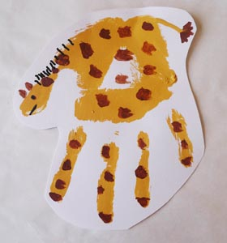
- Let’s get messy
- Can you make some giraffe handprint pictures?

- Make some playdough using flour and water so you can make some models of the different animals. https://www.bbcgoodfood.com/howto/guide/playdough-recipe

- Can you create a magic drink for the animals once they have finished their dance as dancing is hard work. You might use, glitter, grass, soil

- Let’s get moving
- Put on your favourite song and dance along to it. Can you get your family involved too. My favourite song is Pump it Up , I know you all love that one too! https://youtu.be/hRGIrrjuLYA
- Using this ‘Roll a Dance Dice’ you can copy the different dance moves Gerald the Giraffe learns. This is the link for the Roll a Dance dice printable: https://drive.google.com/file/d/0B9LNwFa8gq0yTXpPVHVoLVAxMXM/view
Here is another link to make your own cardboard dice: http://printables.atozteacherstuff.com/435/cube-pattern/

- Let’s take turns

- Take it in turns, saying things we are good at.
- Listen to the different types of music the animals danced to. Which do you like best?
- Name and place the type of feelings Gerald might be having, is he in the green, yellow or red zone?
- Listening to what we can hear? Can you hear birds, the wind, traffic?

Here are some links to songs or other resources that can also link into the story that you might want to look at:
The book sung with pictures of real animals: https://www.youtube.com/watch?v=62O9EjrEVUc

