Preparing for Adulthood Family Information Event
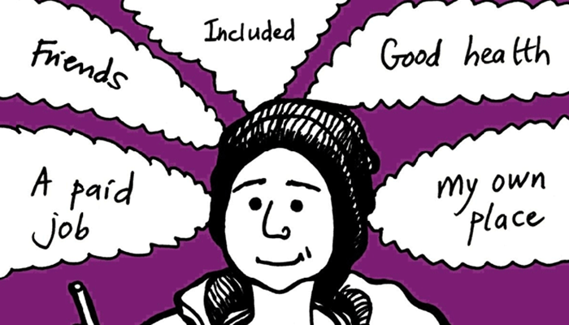
Saturday 23rd March 2019
10:00-14:00
Harvey Hadden Stadium, Wigman Rd, Nottingham NG8 4PB
(Refreshments will be provided throughout the day)

This event is an opportunity for young people and their families to meet with services and organisations who are available to support with the move into adulthood with particular focus on Education, Employment & Training pathways for Post 16. The event is being supported by a range of services and organisations. There will also be the opportunity to get involved and take part in both sporting and art workshops on the day.

If you are interested in attending this event please complete and return the below reply slip in the envelope provided or email us by no later than Friday 1st March 2019
We look forward to seeing you all on the day!

Services at the event:
Futures Career Advice & Apprenticeships | Information regarding Supported Employment
Skills For Employment | NCC Transitions Team
Specialist Colleges | Mainstream Colleges
Adult Overnight Short Breaks Services | Independent Travel Training
Information, Advice & Guidance Services | Sports, Leisure & Community Opportunities
Community Short Break Providers | Nottinghamshire Participation Hub

Directions (Click Map Below)
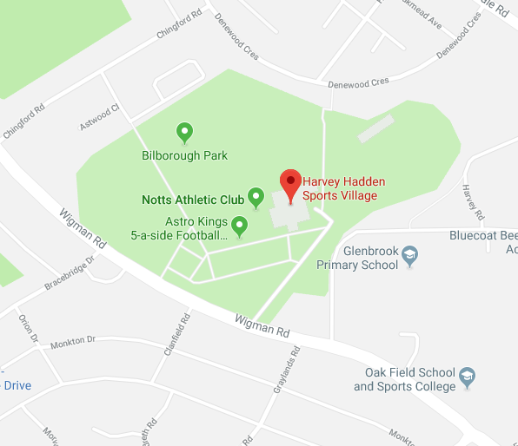

Reply Slip

I will / will not be attending the Preparing for Adulthood Event (please delete as appropriate):

Name:
D.O.B:

The following people will be accompanying me:

Please return this reply slip to:
PFA Event -ICDS Assessment Team, Meadow House, Littleworth, Mansfield, NG18 2TB

OR

Please Email confirming your attendance to:
ICDS.EOTAS@nottscc.gov.uk

